Demonstration 1 – Running Docker in Swarm Mode

Solution:

Create 3 ubuntu instances on GCP with Docker engine installed on them

Docker -1

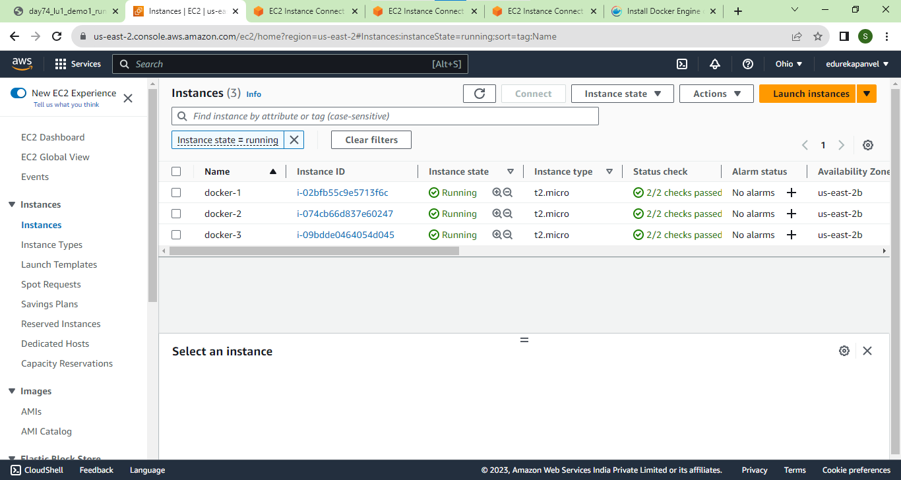

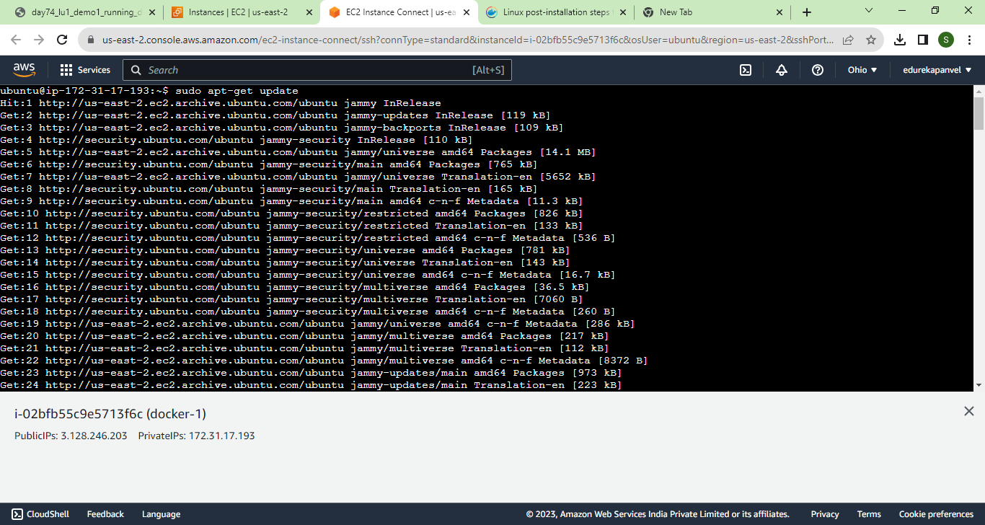

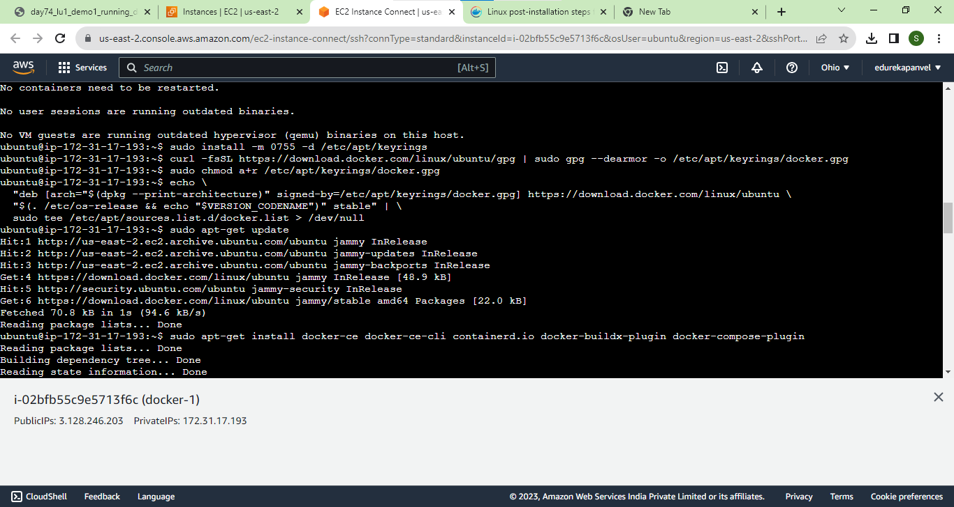

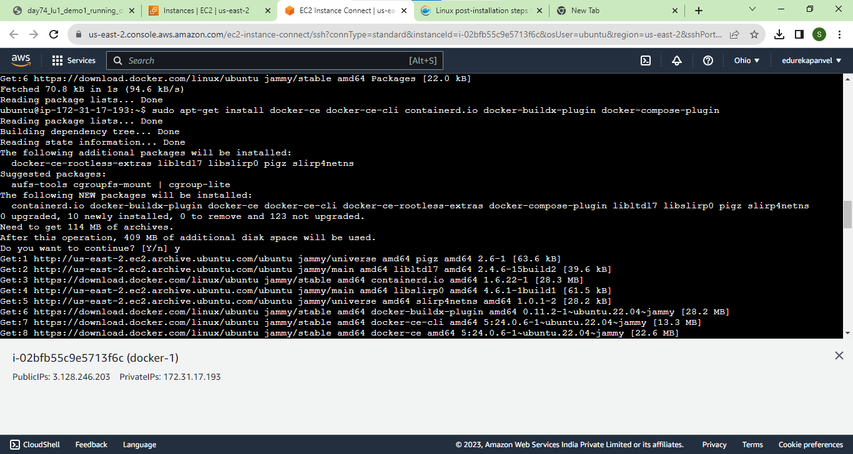

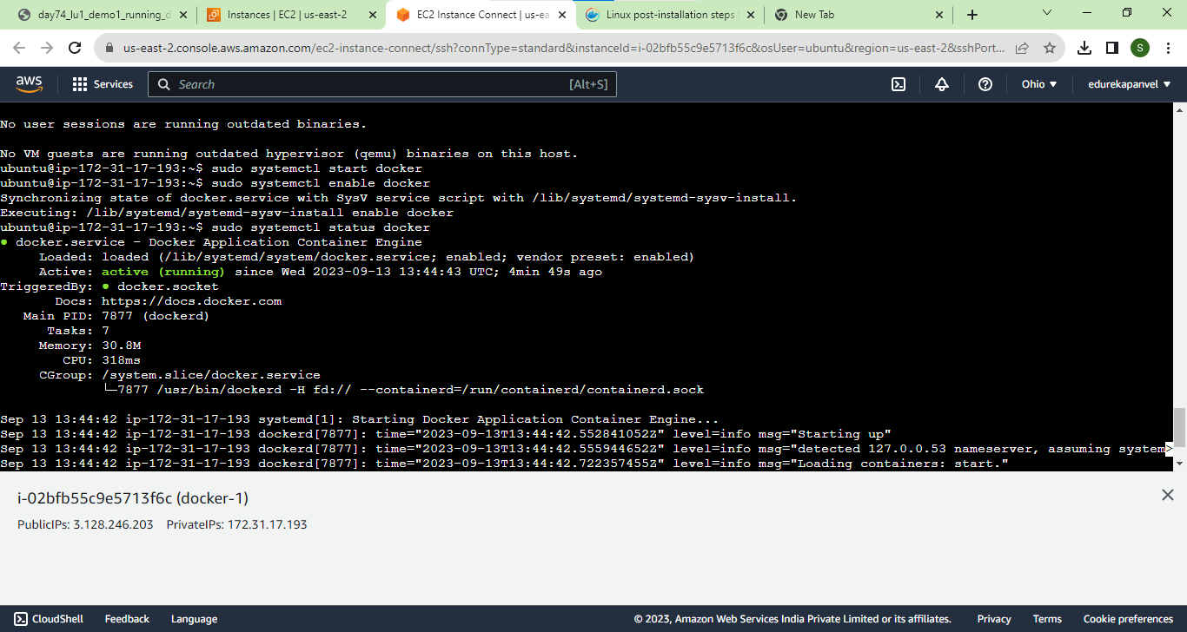

Docker 2

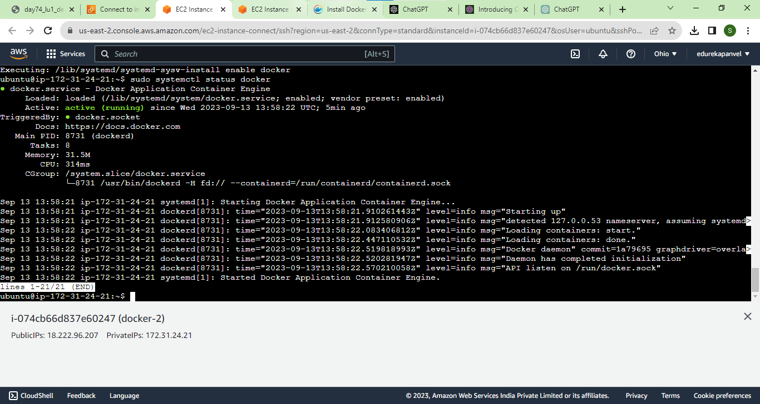

Docker-3

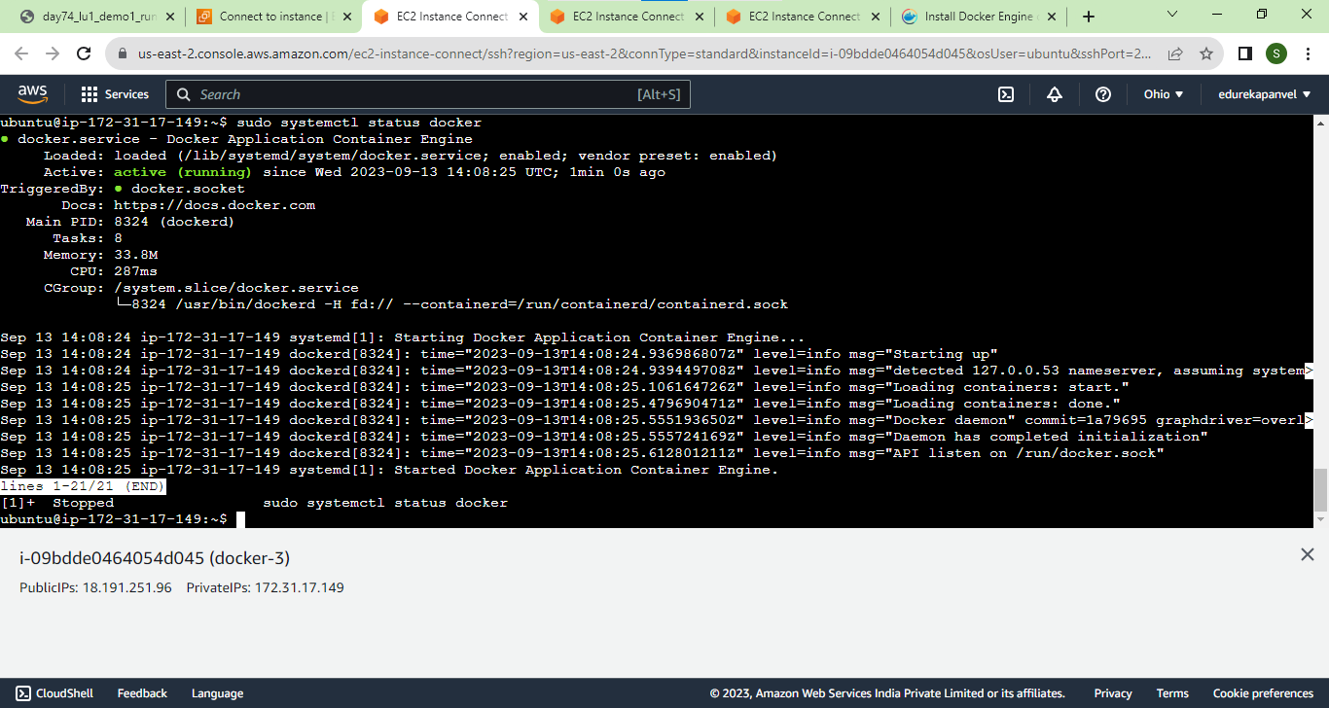

Add security rules for TCP 2377, TCP and UDP 7946, and UDP 4789

Docker 1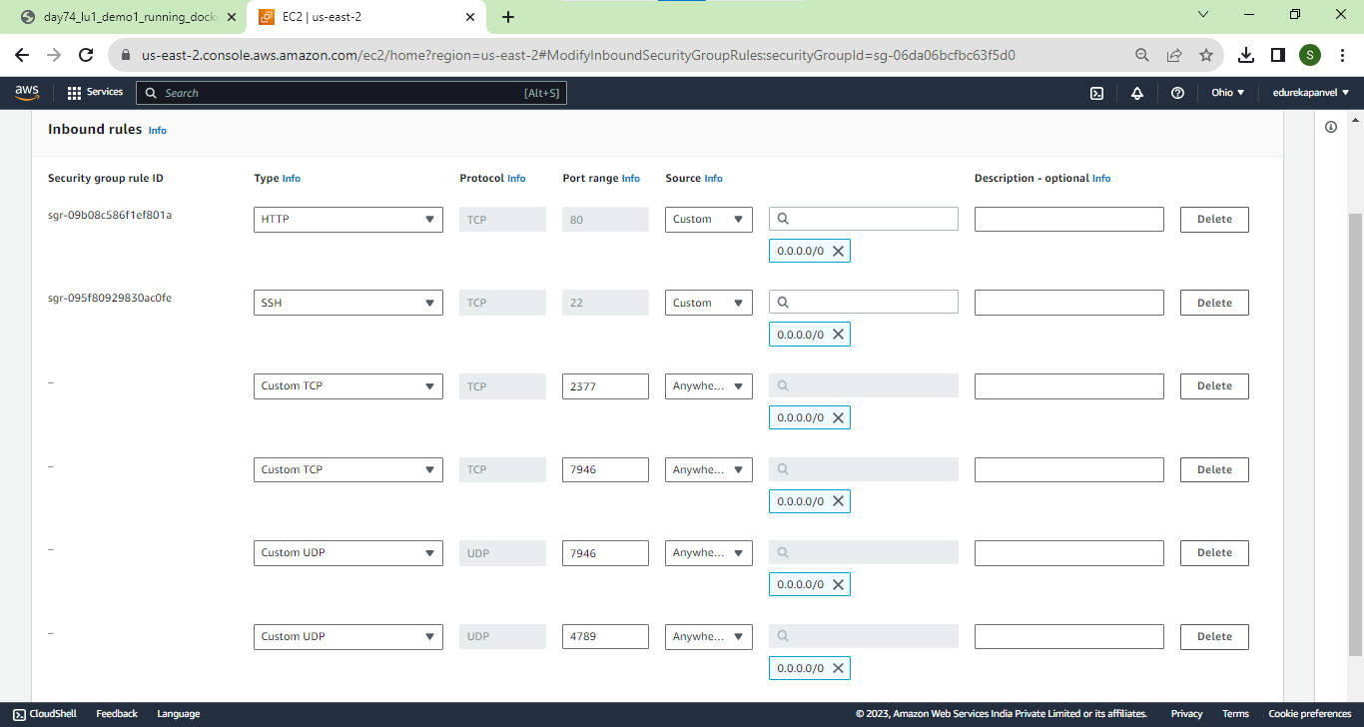

Docker 2 and docker 3

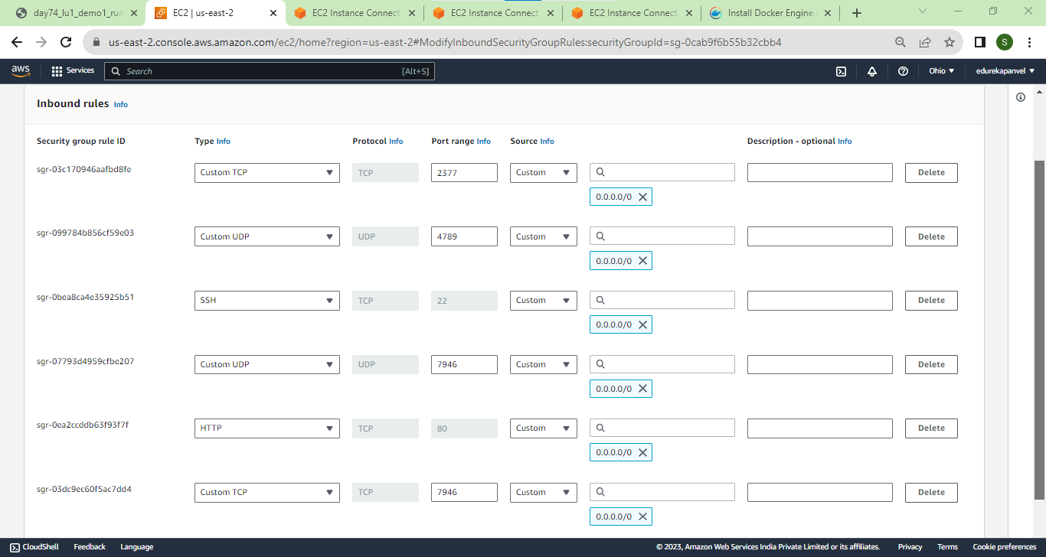

Docker -3

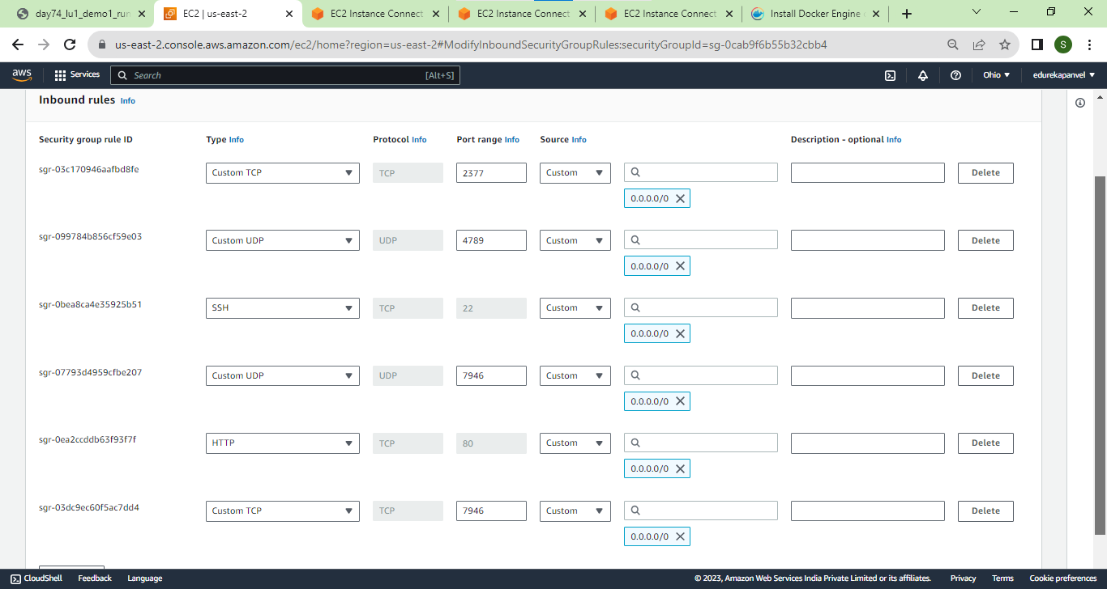

manager node run the following command to initialize a swarm cluster

In case, you have lost the output, the join command can be obtained by running the following command

$ docker swarm init --advertise-addr

$ docker swarm join-token worker

On the manager node run the node ls command to check all the connected nodes in the cluster

$ docker node ls

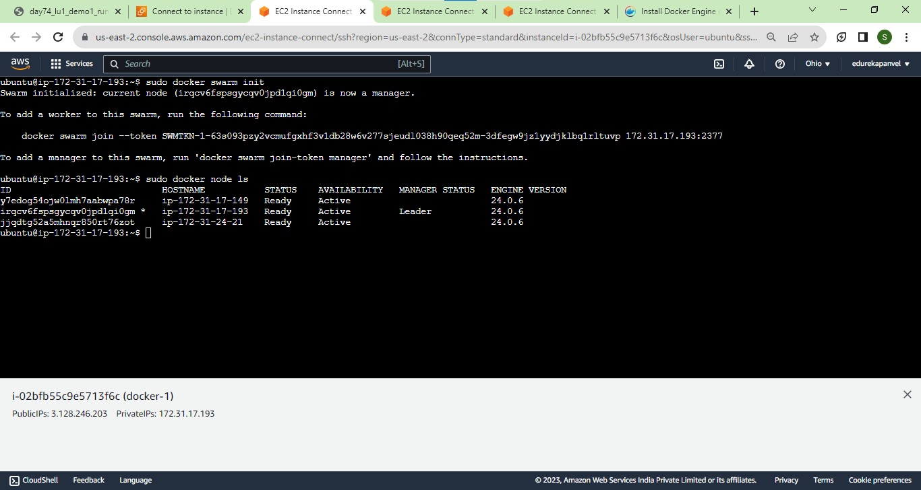

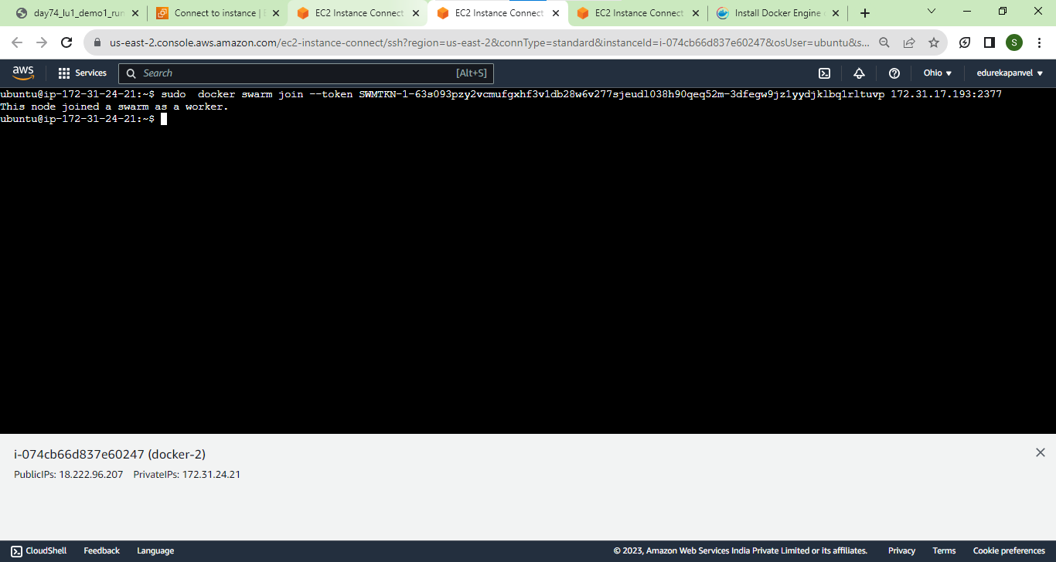

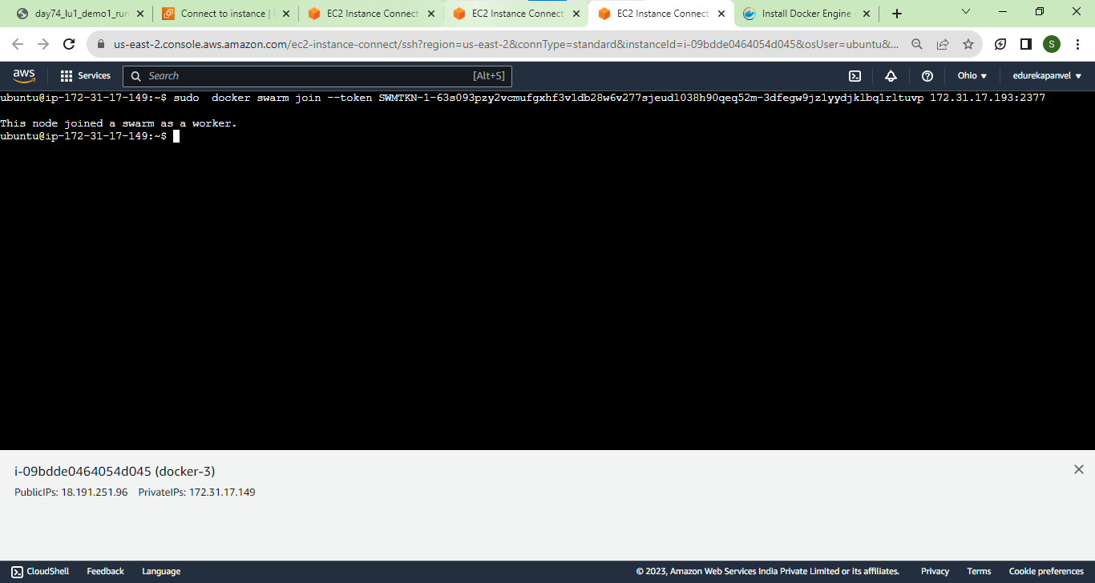

Docker Swarm and Docker Service Demonstration 2 – Scaling Services

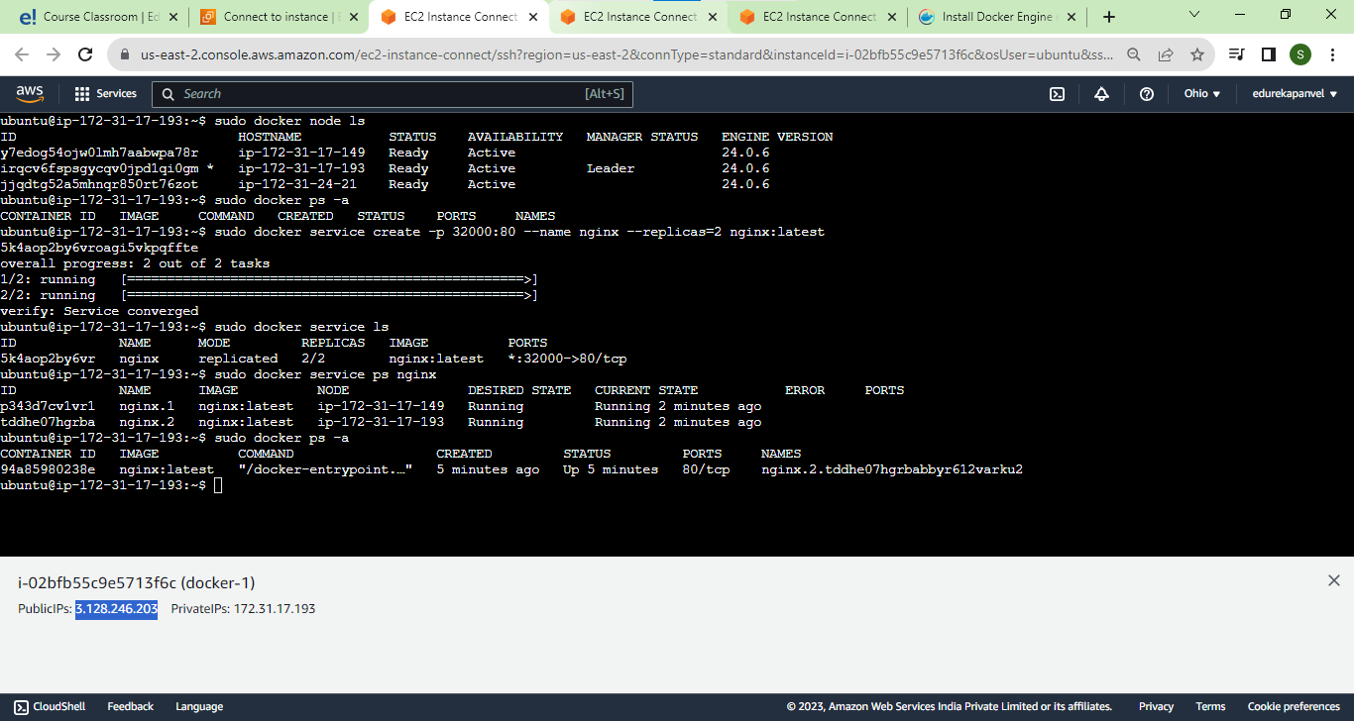

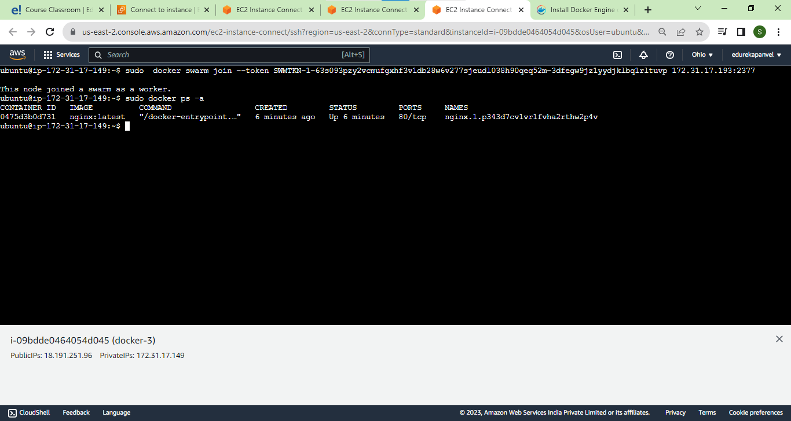

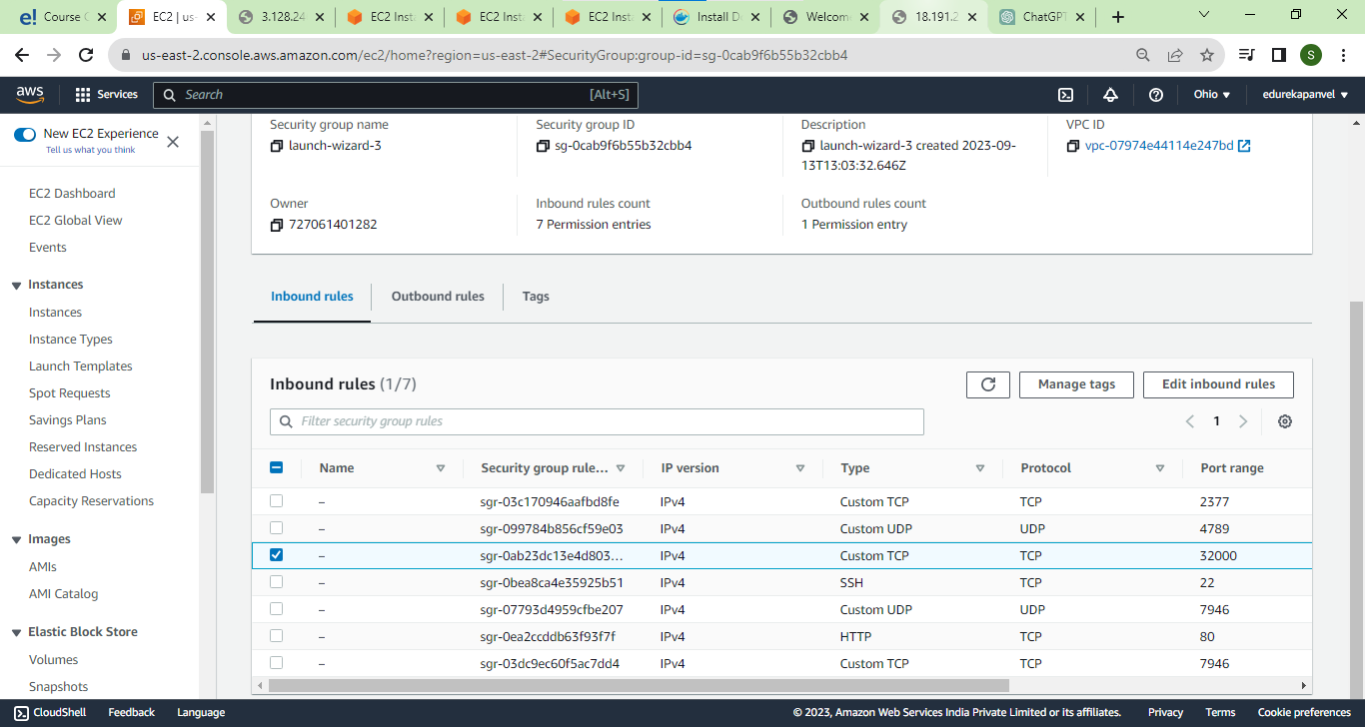

Remember on both instace allow port which you set

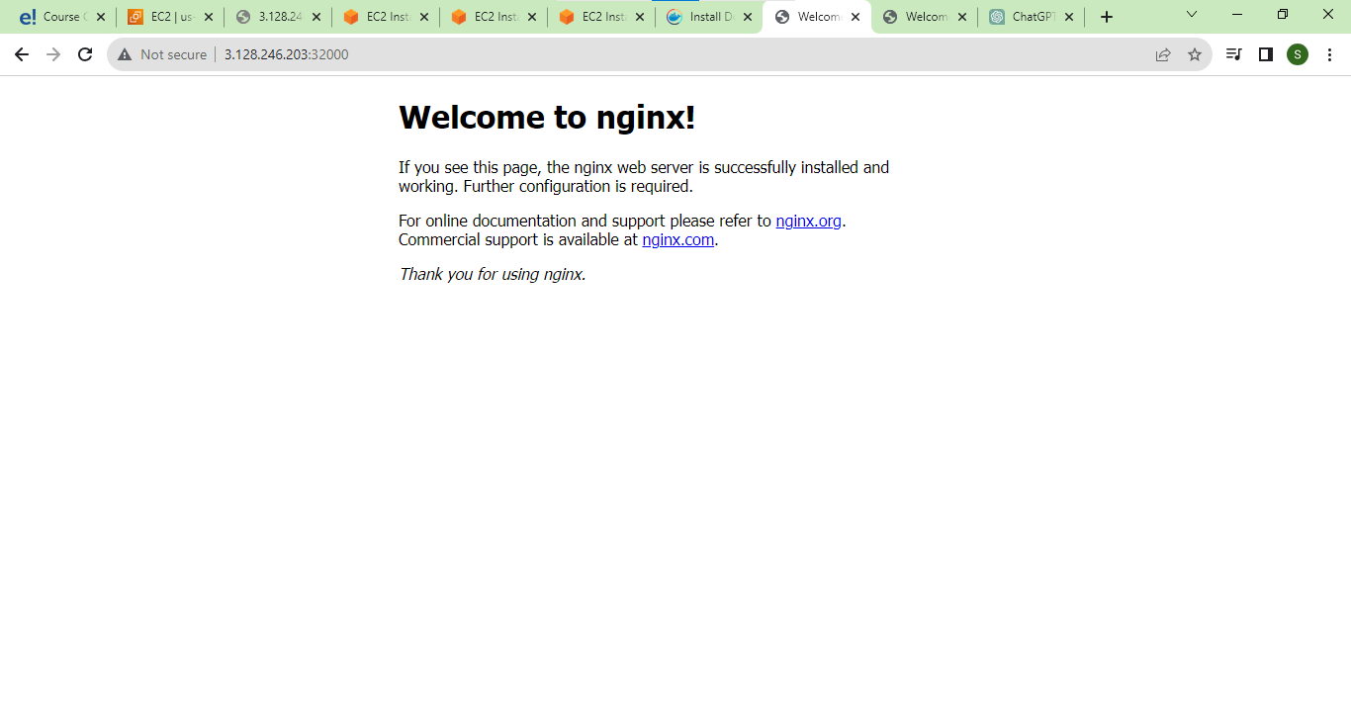

Also on 3rs 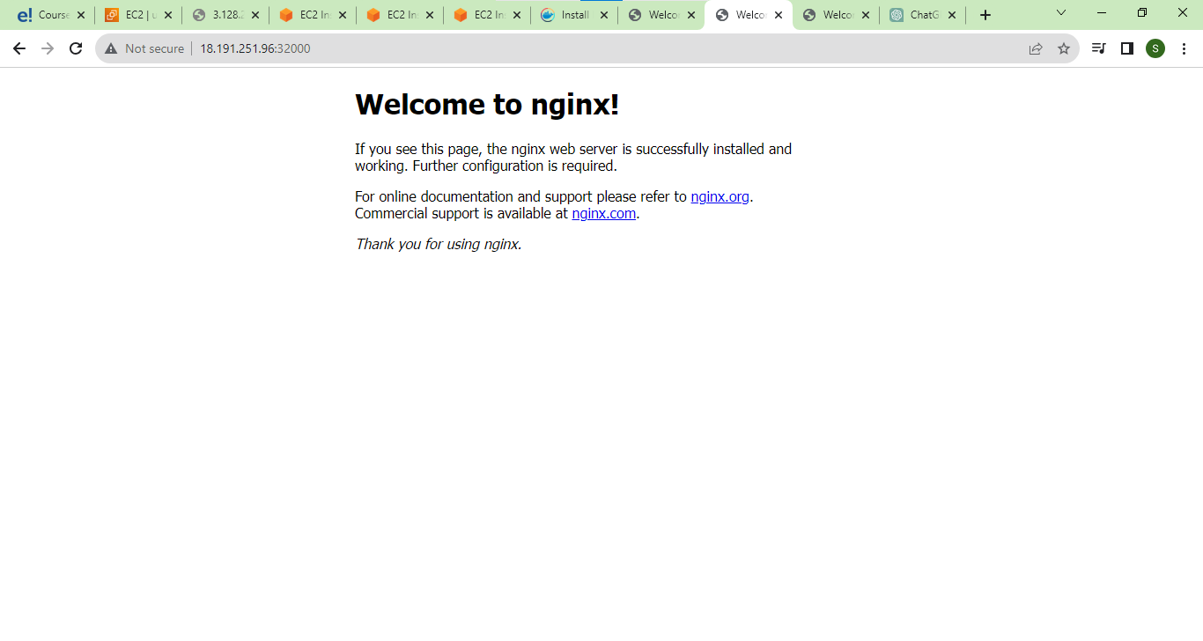

Also on 2

On 2nd container is nor running but also it shows in browser

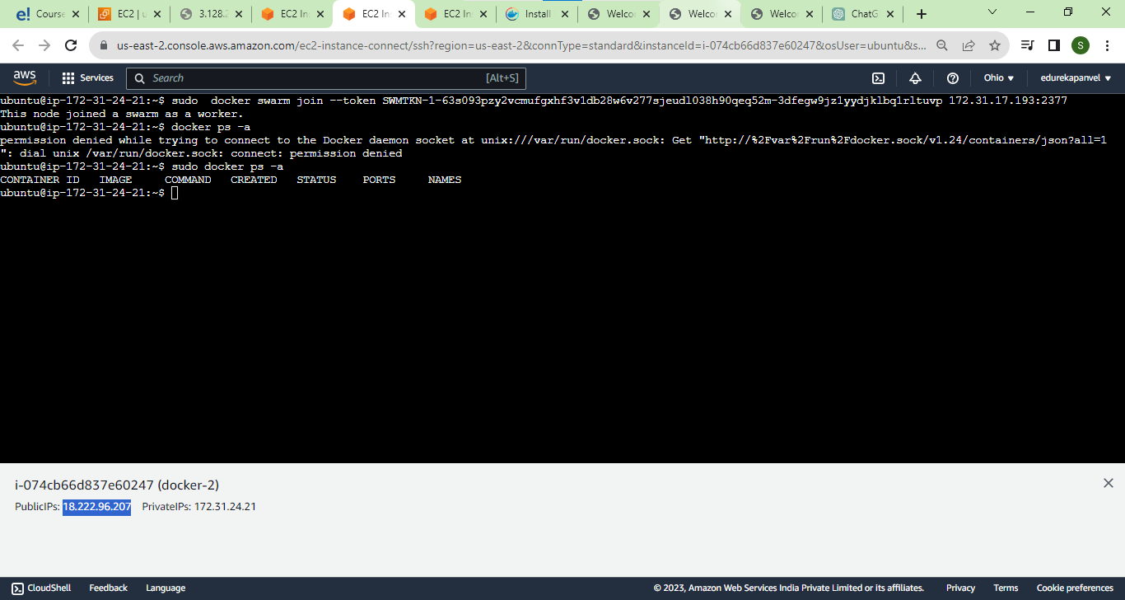

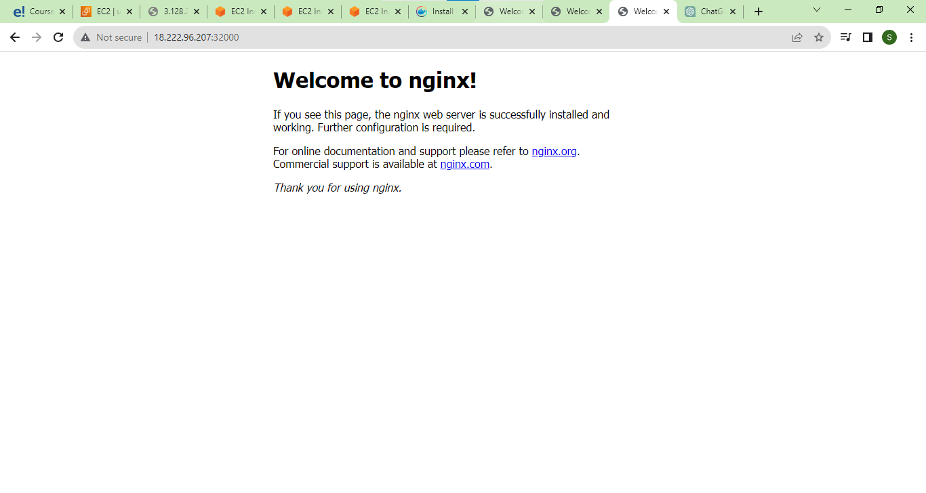

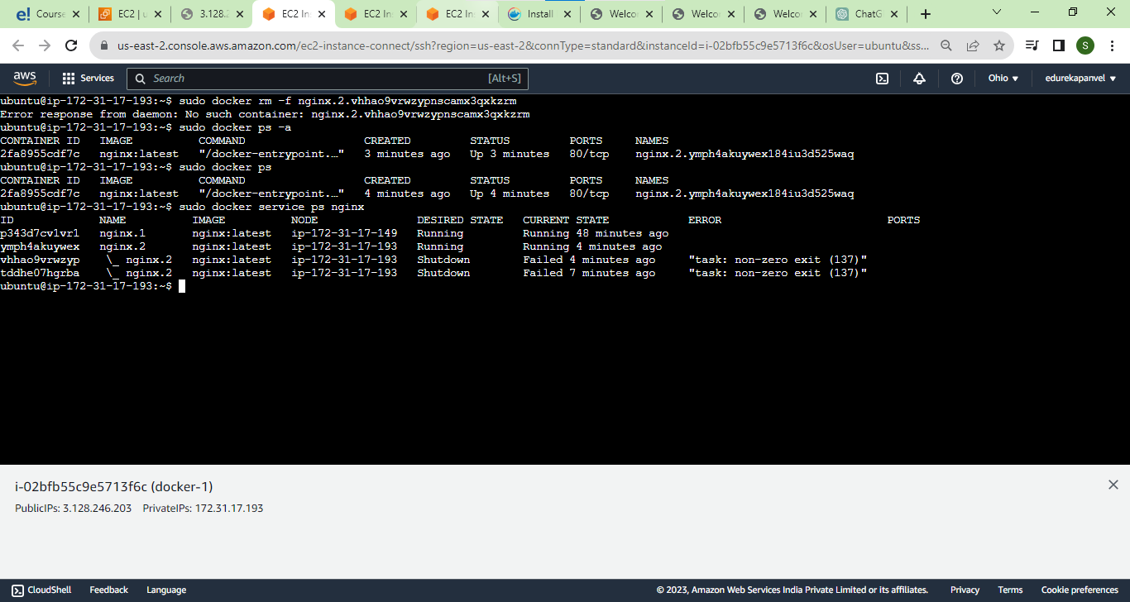

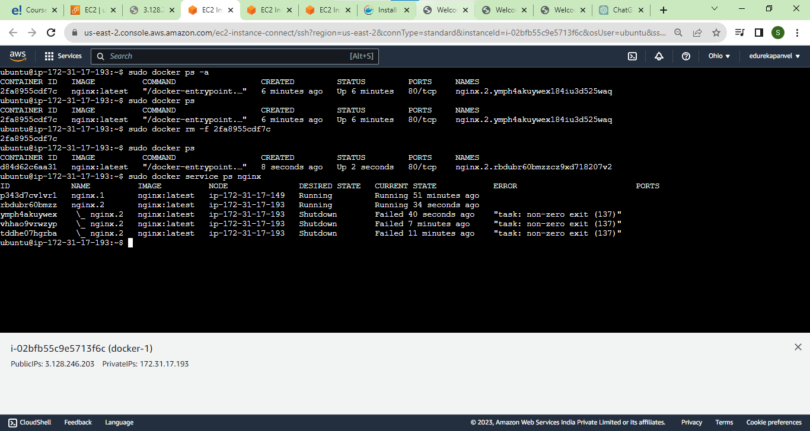

Demo2 scalling service

Docker service rm nginx

Docker service ps nginx

Docker service ls

Sudo docker ps –a

Docker service scale nginx=4

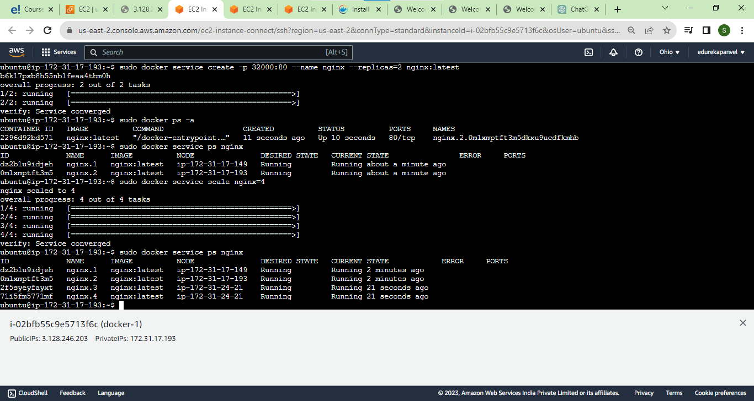

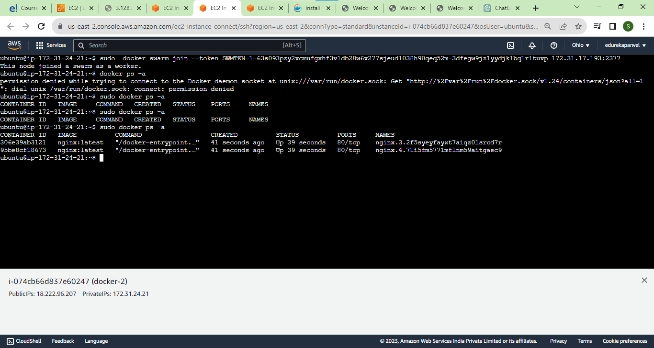

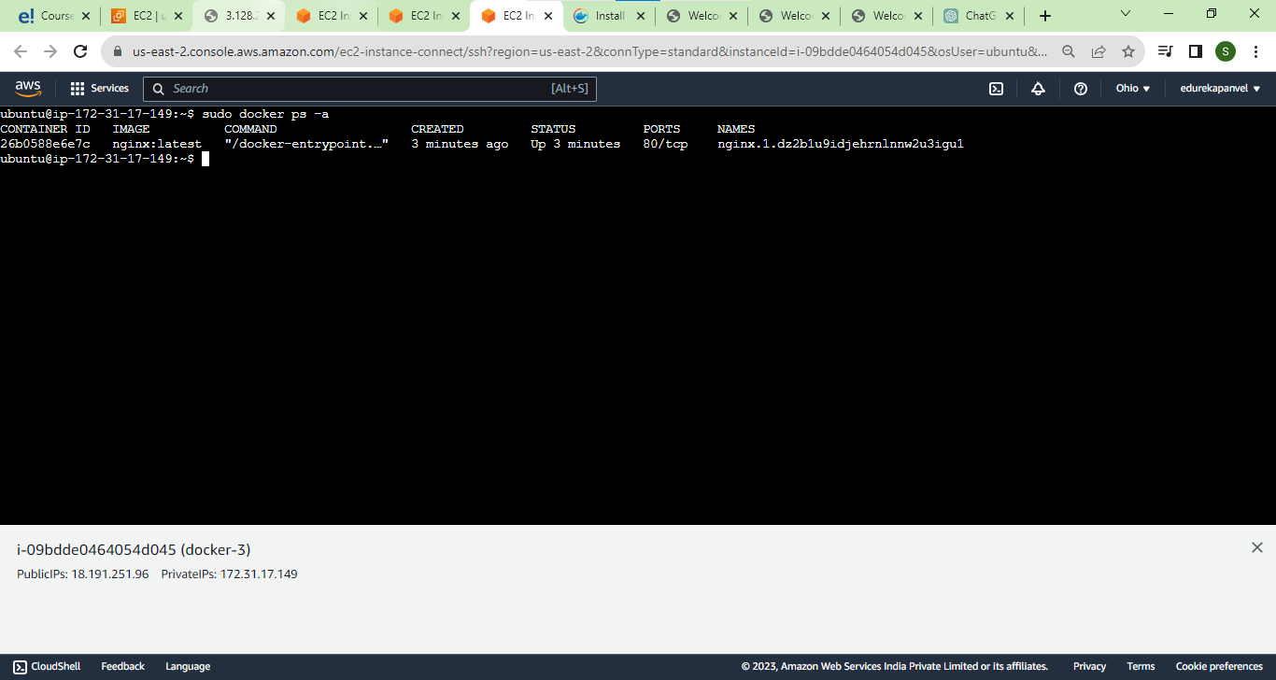

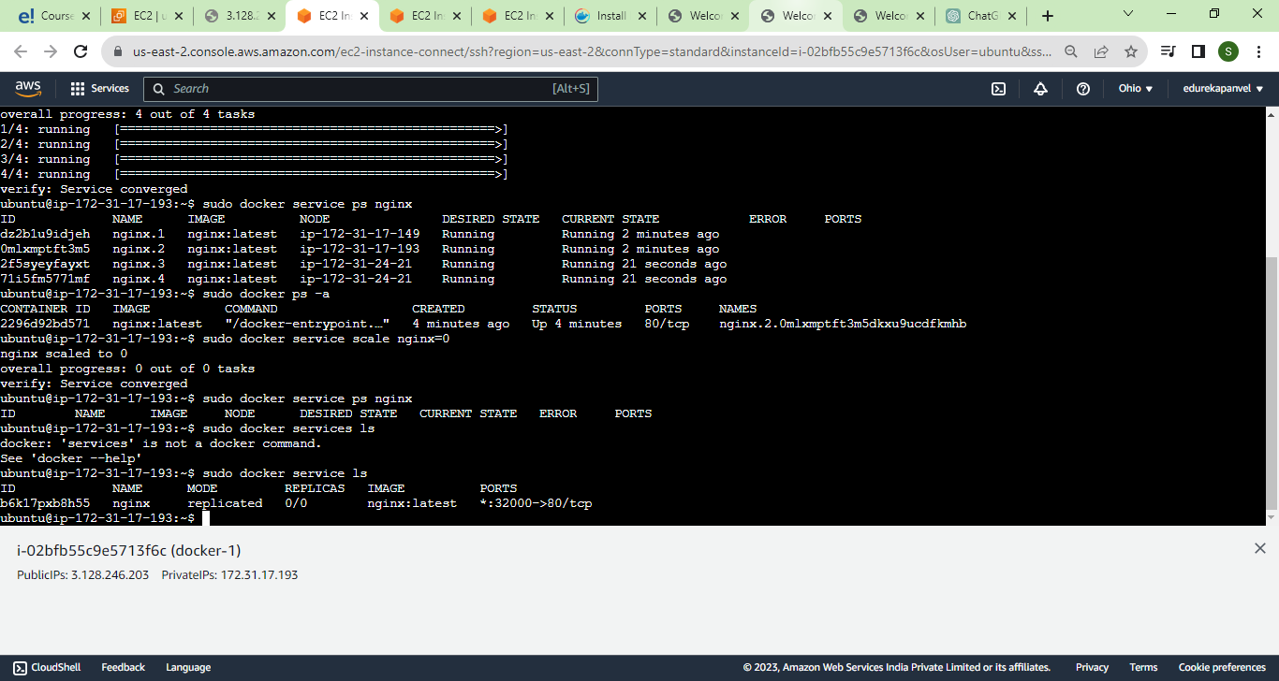

verify: Service converged

ubuntu@ip-172-31-17-193:~$ sudo docker service ps nginx

ID NAME IMAGE NODE DESIRED STATE CURRENT STATE ERROR PORTS

dz2b1u9idjeh nginx.1 nginx:latest ip-172-31-17-149 Running Running 2 minutes ago

0mlxmptft3m5 nginx.2 nginx:latest ip-172-31-17-193 Running Running 2 minutes ago

2f5syeyfayxt nginx.3 nginx:latest ip-172-31-24-21 Running Running 21 seconds ago

71i5fm5771mf nginx.4 nginx:latest ip-172-31-24-21 Running Running 21 seconds ago

ubuntu@ip-172-31-17-193:~$ sudo docker ps -a

CONTAINER ID IMAGE COMMAND CREATED STATUS PORTS NAMES

2296d92bd571 nginx:latest "/docker-entrypoint.…" 4 minutes ago Up 4 minutes 80/tcp nginx.2.0mlxmptft3m5dkxu9ucdfkmhb

ubuntu@ip-172-31-17-193:~$ sudo docker service scale nginx=0

nginx scaled to 0

overall progress: 0 out of 0 tasks

verify: Service converged

ubuntu@ip-172-31-17-193:~$ sudo docker service ps nginx

ID NAME IMAGE NODE DESIRED STATE CURRENT STATE ERROR PORTS

ubuntu@ip-172-31-17-193:~$ sudo docker services ls

docker: 'services' is not a docker command.

See 'docker --help'

ubuntu@ip-172-31-17-193:~$ sudo docker service ls

ID NAME MODE REPLICAS IMAGE PORTS

b6k17pxb8h55 nginx replicated 0/0 nginx:latest \*:32000->80/tcp

ubuntu@ip-172-31-17-193:~$ sudo docker service rm nginx

nginx

ubuntu@ip-172-31-17-193:~$

